THE ROTTING HART
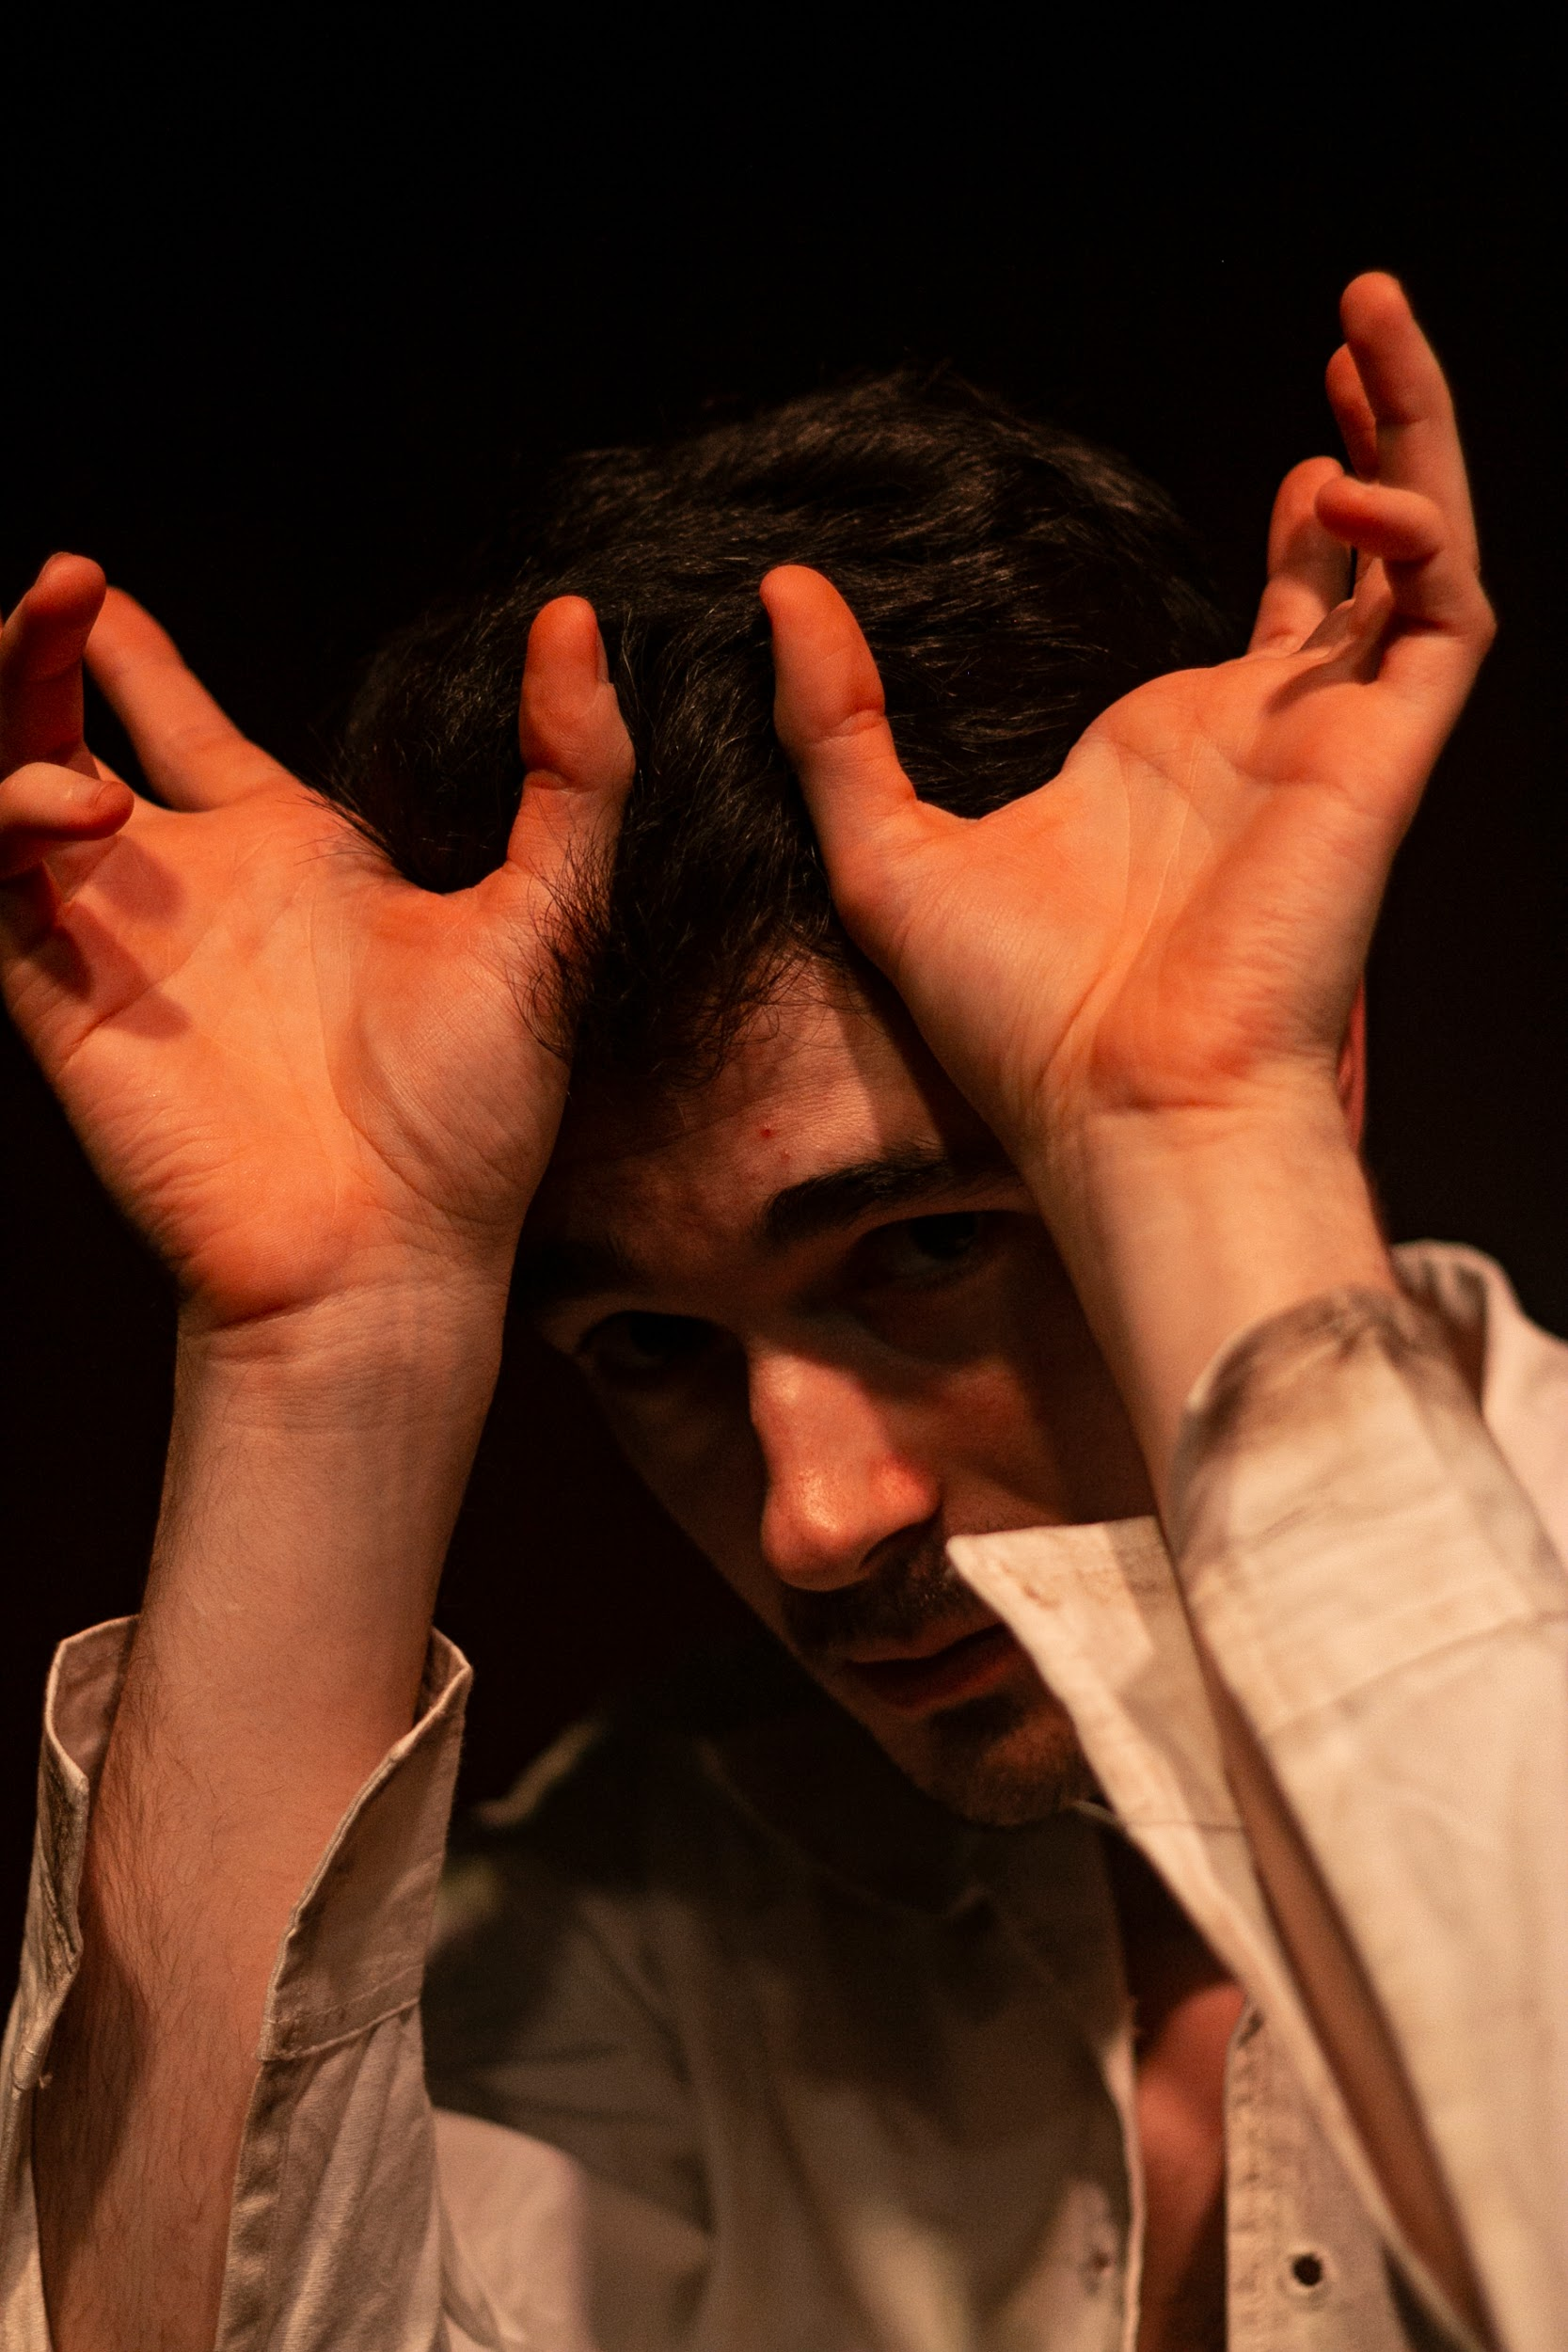
ACCESSIBILITY GUIDE

Daniel Orejon (HIM) in The Rotting Hart.

INDEX
ABOUT THIS GUIDE 2
ABOUT THE PERFORMER 2
ABOUT THE SHOW 3
Trigger Warnings 3
When You Arrive 3
Interacting with the Audience 3
Lights and Sound 3
Props 4
THE CHARACTERS IN THE SHOW 4
HIM 4
Diego 4
Father 5
History 5
THINGS TO KNOW 5
Part 1 5
Part 2 6
Part 3 6
Part 4 7
Part 5 8
ANTIGAY LEGISLATION 8

ABOUT THIS GUIDE
This guide is designed to offer audiences attending a performance of The Rotting Hart with as much information as they might need regarding the production, the playtext, and the team, in order to make their attendance enjoyable and comfortable.

Due to the nature of the show, we do not hold relaxed performances per se. However, audiences are more than welcome to do as they need in order to feel at ease during our performances. If at any point during the show you feel the need to leave the auditorium, please do so - you can always return if and when you feel ready. Audiences are also welcome to come chat to the cast after the show has finished.

ABOUT THE PERFORMER
The Rotting Hart is a solo show and as such there is only one member of the cast: Daniel Orejon. Daniel is an Edinburgh-based theatremaker and performer and, apart from acting in The Rotting Hart, he also wrote it. He is bilingual and completely fluent in English and Spanish, so feel free to say “hi” in either language at the end of the show if you want to. He is also queer and has a deep connection with some of the themes explored in the show.

ABOUT THE SHOW
The Rotting Hart is a queer horror show. It explores some of the toxic dichotomies that pervade the gay community while also delving into the history of antigay legislation in Spain throughout history. As you can probably guess, it’s not a very cheery show.

Trigger Warnings
There are some trigger warnings that audiences might want to be aware of when attending the show, including sex, violence, gore, animal cruelty, death and homophobia. More details as to how these trigger warnings manifest during the show appear later in this guide.

When You Arrive
When you arrive at the auditorium, you will find the performer, Daniel, topless and lying on the stage, huffing in pain and trying to stand up, as well as a wooden chair lying beside him. This is already part of the show so try not to interact with Daniel at this point - remember, you can always chat with him at the end of show.

You will find a paper copy of the programme on about half of the seats in the venue. You can either take one or, if there are none available, ask to borrow one from the audience members around you. This programme includes information on all the people who have been involved in the creation of the show as well as English translations of five pieces of antigay legislation that Daniel performs in their original language (Latin, Old Spanish and Spanish) throughout the show. You can read these before the show starts, during the show as the original texts are performed, or afterwards. In case you cannot get your own copy of the programme, you can find all five translations at the end of this document.

Interacting with the Audience
The show is about 1 hour long and includes a lot of direct audience address. What this means is that, throughout the show, Daniel will be delivering a lot of his lines to members of the audience, looking them in the eye as he does this, and even sometimes asking them questions. You do not need to respond or react to Daniel if he addresses you, even though at times he might act as if he wants you to.

Apart from talking to the audience, there are no other types of audience interaction in the show. You will never be asked to come onto the stage, hold any props, or affect the plot in any way. Twice during the show Daniel will go down the aisle but he will not walk among the audience seats.

Lights and Sound
If you are attending an unteched version of the show (such as our performances at Durham and Edinburgh), there will be no changing lights or prerecorded sound during the show. There will be some static lights aimed at the stage so that you can see Daniel during the show but that’s about it.

There might also be some theatre smoke, which we use to make the space a little bit spookier and more atmospheric. This smoke is completely safe and harmless. It has a slightly odd scent (a bit like cotton candy) but it’s very faint so you might not even notice. The smoke is not thick at all so you’ll be able to see where you’re going as you arrive at the venue. By the end of the show, the smoke will have mostly dissipated.

If you are attending a teched version of the show, there will be light changes (including a blackout at the very beginning and end of the show), sound effects, and music. More details on what these look and sound like can be found later in this guide.
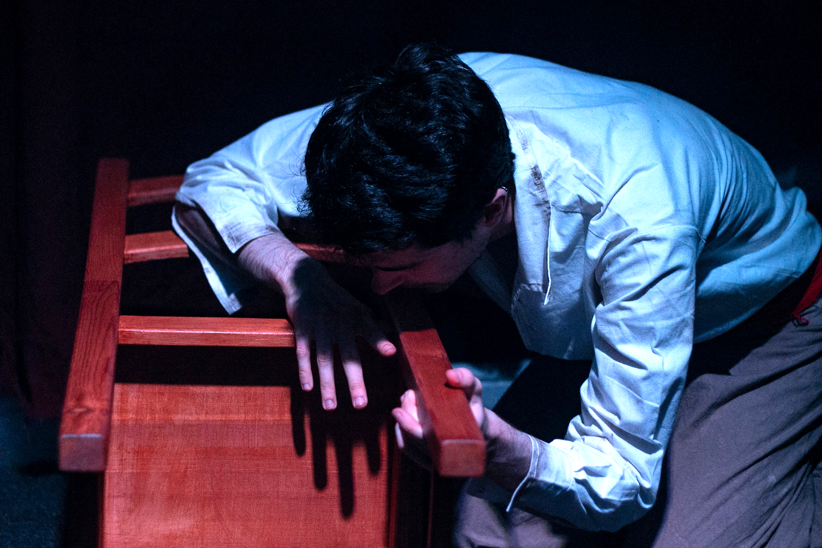
Props
There is only one prop in the entire show: a wooden chair. Throughout the show Daniel will sit and stand on this chair, but he will also use it as if it were an old gun (a caliver), a horse, and other characters in the show.

THE CHARACTERS IN THE SHOW
Throughout the show, Daniel will mostly perform as HIM, the main character in the play. However, at times he will pretend to be DIEGO, FATHER or HISTORY.

Him
HIM is a young man, between 20-25 years old, who lives alone with his father in the valleys of Toledo, Spain. At the beginning of the story, Diego comes to live with HIM and his father. Initially, HIM doesn’t like Diego, but then he starts developing feelings for him, feelings he doesn’t understand. HIM is the character that Daniel pretends to be for most of the show - he is the character that is describing what is happening and that talks to the audience.

Diego
Diego is another young man, around the same age as HIM. He comes to live with HIM and his father at the beginning of the play. He usually stands straighter than HIM and holds his hands in front of himself, with his thumbs pinching onto each other. He is literate and can speak a bit of Arabic.

Father
HIM’s father is a peasant and a hunter. He is between 35-40 years old. He lives with his son isolated from the rest of the world. He doesn’t speak much and usually points at things when he talks to HIM.

History
History is not a real person per se. He performs the sections of antigay legislation in their original languages, almost as if he was lecturing the audience… or warning them. He combines this with physical choreography, moving his arms and legs in a manner that you are free to interpret however you want. You can tell Daniel is performing as History when he takes a deep breath in and out, holds his hands in front of himself as if they were a book, and speaks with a more nasal voice.

Whenever Daniel speaks lines belonging to DIEGO or FATHER, he will say them in Spanish. Sometimes these lines are explained straight after they’re spoken and sometimes you can infer what they meant based on what’s happening; however, there are times when you might not guess what they mean… and that’s ok! That’s part of the show. Whenever you don’t understand the lines in Spanish, it’s probably because HIM also doesn’t understand what’s going on.

THINGS TO KNOW
Here is a brief guide describing how a normal unteched performance of The Rotting Hart should go, including moments of intense movement or sound and points where trigger warnings are relevant.

Part 1
- This section of the play describes how Diego arrives at HIM and his father’s cottage one day and the hunting excursion all three go on straight after.
- The section begins with Daniel quietly singing a Spanish song as he rises from the floor.
- Early in this section, Daniel will interact with the wooden chair as if it were a horse. He will then mime to strike the horse on the forehead with a beater (by slamming the chair against the floor, which can make an audible thud) before slicing the horse’s neck, which kills it (TW: animal cruelty, death). He then cuts the carcass into parts (slamming the chair against the floor three times) and mimes throwing said parts into the audience.
- The section ends with Diego preparing to shoot a deer. We don’t see the shooting though; instead, the action cuts to History doing the first of his five antigay legislation sections, ‘Article 456, Third Chapter “Crimes of public scandal”, Title IX of the Criminal Code, year 1870’:
The maximum penalties of arrest and public repression will be imposed on those who howsoever offend civic modesty or honest decorum with acts of severe scandal or transgression not expressly referred to in other articles of this Code.

Part 2
- This section of the play describes how HIM and Diego start interacting, how Diego convinces HIM to visit the abandoned monastery beside their cottage, and how HIM panics after Diego reads him an 11th-century homoerotic Hispanoarabic poem.
- Halfway through this section, History will do the second of his five antigay legislation bits, ‘From the Canons of the Sixteenth Synod of Toledo, year 693’:
Just as the cleansing of men’s hearts and bodies brings them closer to God, so does the contrary, the practice of incestuous blunders, casts them away from Him. And just as that horrendous, nefarious crime condemned the sodomites to the scorching fires from the heavens in times past, so too will these same flames of eternal damnation consume those men who fall prey to such filths. For the Lord said through his prophet: “Those garments rolled in blood shall be burnt and fuel for the flames”.
- Two thirds of the way through this section, HIM will walk down the aisle whilst he tells the story of how the monastery came to be. At one point he will make a loud thudding sound with his fist against a wooden surface (a door or the floor) - this only lasts about ten seconds. He remains amongst the audience until he rushes back to the stage and jumps on his wooden chair.
- Soon after, HIM gets very upset at Diego. He raises his volume and describes how he would like to tear Diego apart (TW: violence, gore). He shouts the last two lines of this bit - this lasts about five seconds.
- History then does the third of his five antigay legislation bits, ‘First Law, Royal Decree of the Catholic Monarchs Ferdinand and Isabella, year 1497’:
For among all the sins and crimes that offend God our Lord and defile our land, of special note is the crime committed against natural order, against which all laws and decrees must arm themselves.
- The section ends with a quiet conversation between HIM and Diego.

Part 3
- This section of the play describes how Father leaves for a couple of days, how HIM has a physical confrontation with Diego after he reveals he missed his shot from Part 1 on purpose, and how this physical confrontation develops into violent yet consensual sex.
- A third of the way into this section, HIM and Diego have a physical confrontation (TW: violence). Daniel shows this by moving the chair around and slamming it against the floor a couple of times (which, depending on the floor, can make a pretty loud noise). Then Daniel pretends to punch an imaginary Diego by jabbing at the air whilst slapping his chest with the palm of his hand, which makes a decently audible noise.
- After a few minutes, the violence transitions into a sexual encounter (TW: sex, violence). HIM describes the encounter through a physical transformation: Diego’s jaw cracks into a muzzle, his bloody teeth fall off, and HIM’s legs musculature changes so that he’s standing on the balls of his feet (TW: gore). Daniel will deliver some of the lines in this section quite loudly, particularly the last one, which he shouts.
- After this, History will do the fourth of his five antigay legislation bits, ‘Article 44 of the Civil Code, modified by Law 13/2005, year 2005’:
A man and a woman have the right to get married in line with the provisions established by this Code. This marriage will have the same requirements and effects whether both partners are of the same or opposite sex.
- The section ends with HIM singing in Spanish. He does this on the floor and very quietly.

Part 4
- This section of the play describes how HIM tries to hide after his father returns, how he recalls an old hunting trip with his father, how his father brings men from the nearby village to apprehend Diego and take him away, and how HIM feeds his father to the dogs after discovering he knew about Diego’s queerness.
- Early on in the section, HIM talks about an urge he feels to sink his claws into Diego’s flesh and tear it apart (TW: gore, violence).
- Later on, HIM describes a hunting trip he went on with his father. In this memory, his father has shot a pregnant doe in the neck, and then guides HIM to shoot it in the belly. They take the carcass and discard the unborn fawn (TW: gore, animal cruelty).
- Soon after, a mob of men apprehend Diego, physically assaulting him and dragging him away (TW: violence, homophobia).
- At this point, HIM will sing some more of his Spanish song, this time very loudly and violently.
- Immediately after, History will do the last of his five antigay legislation bits, ‘Second law, Title Twenty-One of the Seventh Part of the Code by King Alfonso The Wise, year 1265’:
Regarding those who commit lustful sin against nature. Any and all citizens can accuse men of sinning against nature. This accusation must be made before the judge of the land where said fault was committed. If it were proven true, they must both die, he who did it as well as he who consented. Had one of them been forced to do it, then he should not receive punishment.
- Later on in the section, HIM’s father is physically assaulted by Diego’s dad (TW: violence). In Spanish, HIM’s father uses a couple of archaic homophobic terms to describe Diego and mentions that Diego has been castrated and burned (TW: homophobia, violence, gore).
- The section ends with HIM dragging his father into the kennels, where their hounds devour him (TW: gore, violence).

Part 5
- This section of the play describes how HIM dreams of Diego being burned at the stake and transforming into a stag, how he goes hunting in the woods and shoots a stag (that is inferred to be Diego), and how he devours it.
- The section opens with a dream sequence where HIM imagines Diego being burned at the stake and transforming into a stag, with his fingers cracking into hooves and antlers piercing through his forehead (TW: gore, violence, homophobia). The dream sequence ends with HIM jumping towards the audience, almost as if about to bite them - but don’t worry, Daniel won’t interact with the audience at all.
- The show ends with a bloody sequence of events where HIM shoots a stag which he believes to be Diego, then gets stabbed by one of the stag’s antlers, then bites the stag in the neck twice (TW: violence, gore). Throughout this sequence, HIM describes his full transformation into a hound, with sharp canines drilling through his gums and his skull cracking into a muzzle (TW: gore).

ANTIGAY LEGISLATION
- Article 456, Third Chapter “Crimes of public scandal”, Title IX of the Criminal Code, year 1870:
The maximum penalties of arrest and public repression will be imposed on those who howsoever offend civic modesty or honest decorum with acts of severe scandal or transgression not expressly referred to in other articles of this Code.
- From the Canons of the Sixteenth Synod of Toledo, year 693:
Just as the cleansing of men’s hearts and bodies brings them closer to God, so does the contrary, the practice of incestuous blunders, casts them away from Him. And just as that horrendous, nefarious crime condemned the sodomites to the scorching fires from the heavens in times past, so too will these same flames of eternal damnation consume those men who fall prey to such filths. For the Lord said through his prophet: “Those garments rolled in blood shall be burnt and fuel for the flames”.
- First Law, Royal Decree of the Catholic Monarchs Ferdinand and Isabella, year 1497:
For among all the sins and crimes that offend God our Lord and defile our land, of special note is the crime committed against natural order, against which all laws and decrees must arm themselves.
- Article 44 of the Civil Code, modified by Law 13/2005, year 2005:
A man and a woman have the right to get married in line with the provisions established by this Code. This marriage will have the same requirements and effects whether both partners are of the same or opposite sex.
- Second law, Title Twenty-One of the Seventh Part of the Code by King Alfonso The Wise, year 1265:
Regarding those who commit lustful sin against nature. Any and all citizens can accuse men of sinning against nature. This accusation must be made before the judge of the land where said fault was committed. If it were proven true, they must both die, he who did it as well as he who consented. Had one of them been forced to do it, then he should not receive punishment.

