A Fairie Tale 2
A Shetland Folktale 3
Bear with Me 4
The Hearth 5
Hear Us and Hasten 6
I Hope Your Flowers Bloom 7
Land Under Wave 8
The Mariner’s Song 9
Me, Myself and Mary (Queen of Scots) 10
No One Is Coming 10
The Rotting Hart 11
Songs from the Last Page 12
Tam Lin 13

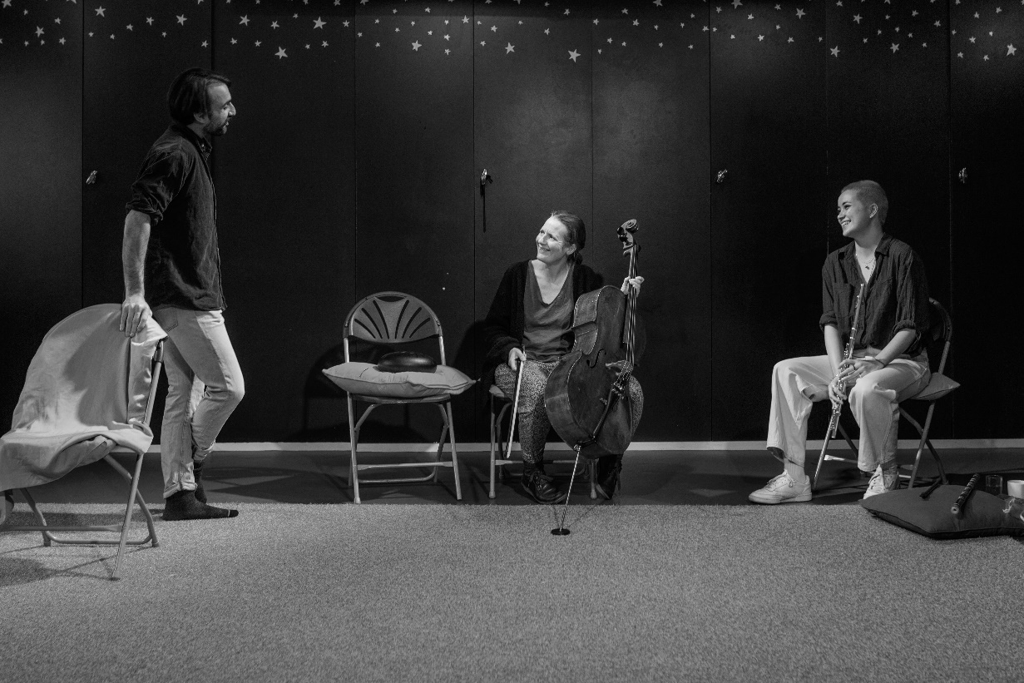

A Fairie Tale
A new and original piece of storytelling exploring queerness, Scottish race and gender identities through a medieval-inspired landscape.
Features one storyteller embodying multiple characters and one musician.
Relaxed Performance Sunday 13th August
- Audience have permission to move around, make noise and engage with the performer during the relaxed performance.
- Readmittance is allowed.
- Show contains one piece of music which will be either adapted or removed for the relaxed performance.
- Show will be sold at limited capacity to allow space between audience members.
- Show guide available.
Which of the following are contained in the show? | Yes/No
Total Audience blackout | Yes
Flashing/Strobed lighting | No
Loud/repetitive/high pitched/unexpected or overlapping sound | No
Distinctive smells | No
Special effects (e.g. smoke/bubbles/pyrotechnics) | No
Latex balloons | No
Characters expressing anger | Yes
Heavily dialogue-driven scenes | Yes
Audience participation | No

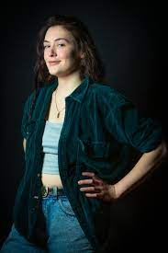

A Shetland Folktale
Marjolein Robertson will tell the story of life in Shetland in the 1800s, exploring crofting, fishing and other traditions. Yet there is more to this story than meets the eye as the characters delve into the magical world of the trows (Shetlandic trolls).
Shetlandic Scots words are used throughout but you do not need to speak or understand it to enjoy the show.

Which of the following are contained in the show? | Yes/No
Total Audience blackout | No
Flashing/Strobed lighting | No
Loud/repetitive/high pitched/unexpected or overlapping sound | No
Distinctive smells | No
Special effects (e.g. smoke/bubbles/pyrotechnics) | No
Latex balloons | No
Characters expressing anger | Yes
Heavily dialogue-driven scenes | Yes
Audience participation | No

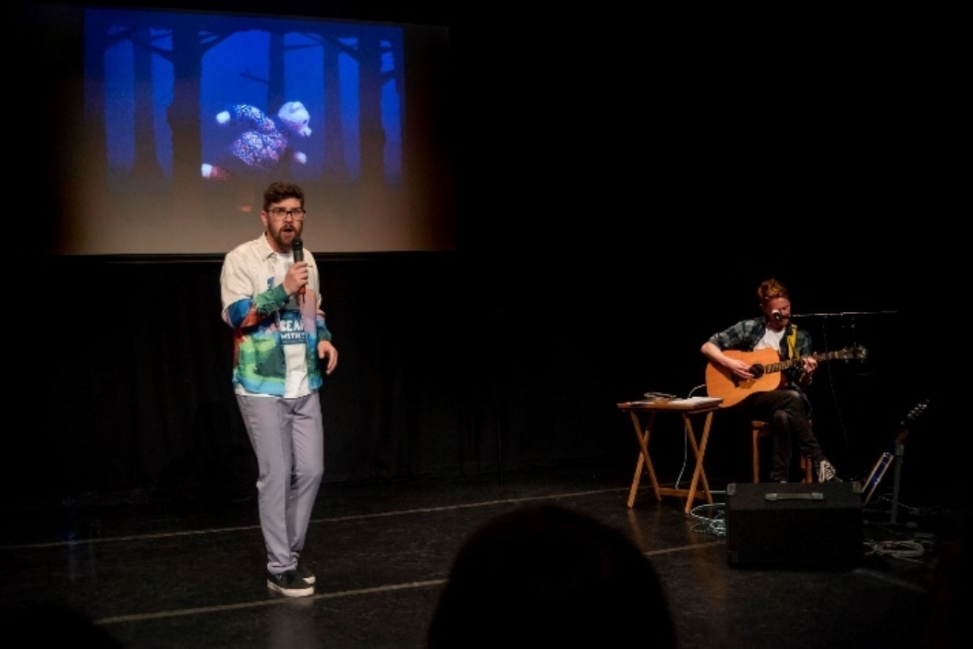

Bear with Me
Spoken word by Stuart Kenny with music by Grant Robertson and animation by Lewis Gillies. The show tells the story of Arty, a day-dreaming, inquisitive young polar bear who was born in Scotland but longs to see the world.
The show is on Spotify now: link to hear the show.

Which of the following are contained in the show? | Yes/No
Total Audience blackout | No
Flashing Lights/Strobed lighting | No
Loud/repetitive/high pitched/unexpected or overlapping sound | No
Distinctive smells | No
Special effects (e.g. smoke/bubbles/pyrotechnics) | No
Latex balloons | No
Characters expressing anger | No
Heavily dialogue-driven scenes | Yes

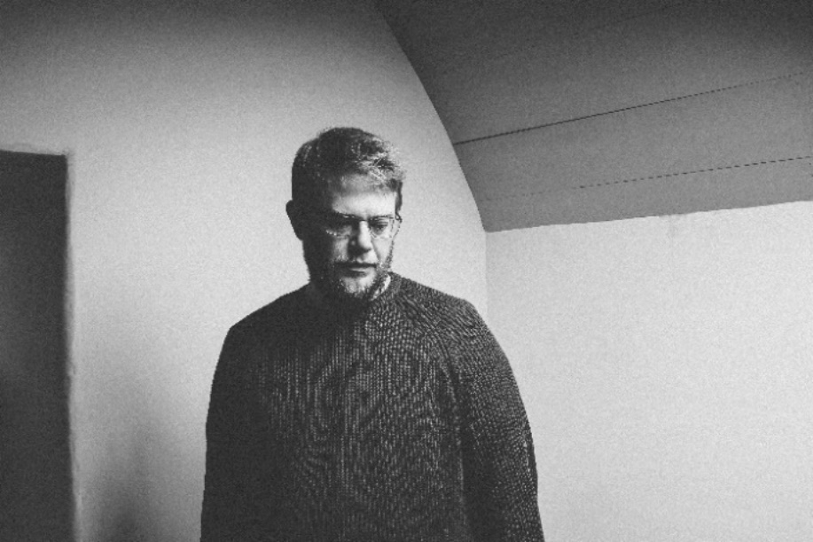

The Hearth

Musician Tom Oakes tells stories inspired by fictional characters and real figures from history to explore how traditions change and evolve.
Solo show with storytelling and music by Tom (pictured). An introduction to the show and characters is part of every show.
Relaxed performance Wednesday 23 August
- Audience members have permission to move around, make noise and engage with the performer.
- Readmittance is allowed.
- The show will be sold at limited capacity to allow space between audience members.
Which of the following are contained in the show? | Yes/No
Total Audience blackout | No
Flashing Lights/Strobed lighting | No
Loud/repetitive/high pitched/unexpected or overlapping sound | No
Distinctive smells | No
Special effects (e.g. smoke/bubbles/pyrotechnics) | No
Latex balloons | No
Characters expressing anger | No
Heavily dialogue-driven scenes | No
Audience participation | No

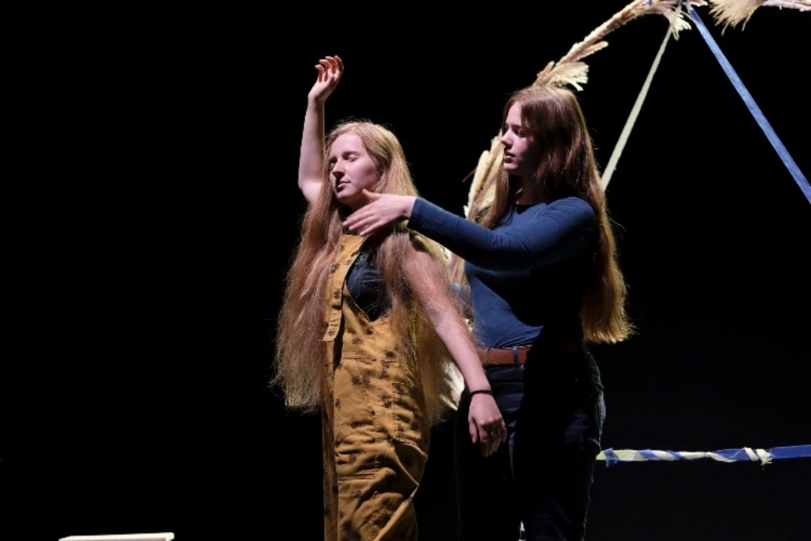

Hear Us and Hasten

Two storytellers will explore themes of nature and climate change through movement and spoken word. Audiences have permission to move around, make noise and engage with the performers during any show.

Which of the following are contained in the show? | Yes/No
Total Audience Black Out | No
Flashing Lights/Strobed Lighting | No
Loud/repetitive/high pitched/unexpected or overlapping sound | No
Distinctive smells | No
Special effects (e.g. smoke/bubbles/pyrotechnics) | No
Latex balloons | No
Characters expressing anger | No
Heavily dialogue-driven scenes | No
Audience participation | No

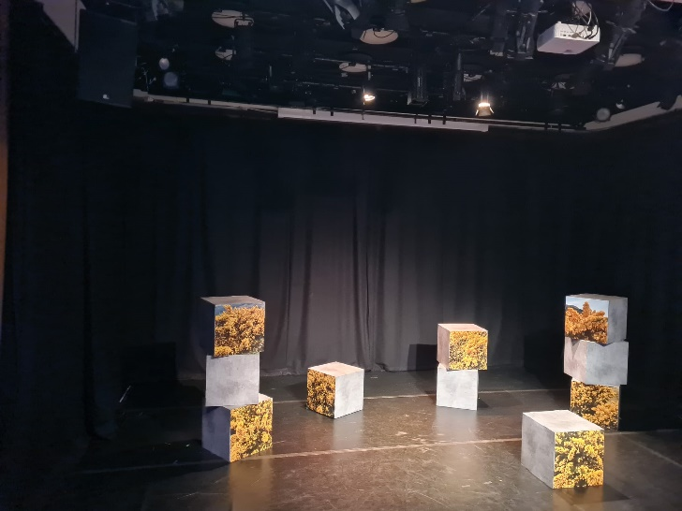

I Hope Your Flowers Bloom

Solo show by Raymond Wilson. Contains storytelling and descriptions of nature including scientific names.
BSL Interpreted Performance: Thursday 10 & Saturday 19 August
Captioned Performance: Thursday 17 & Thursday 24 August
Socially Distanced Performance: Sunday 6 August
Which of the following are contained in the show? | Yes/No
Total audience blackout | No
Flashing lights/strobed lighting | No
Loud/repetitive/high pitched/unexpected or overlapping sound | No
Distinctive smells | No
Special effects (e.g. smoke/bubbles/pyrotechnics) | No
Latex balloons | No
Characters expressing anger | No
Heavily dialogue-driven scenes | No
Audience participation | No

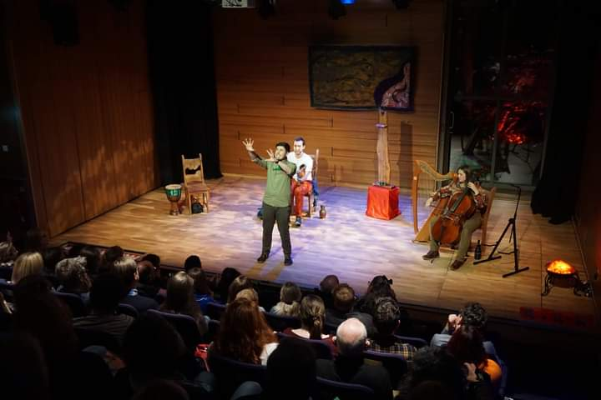

Land Under Wave

Three storytellers play three characters who are trapped in the land of the fae. They must compete to tell the best story to earn their freedom. The audience decides which of them wins and can escape back to the human realm.
There is music and speech often happening at the same time throughout this show. Audience participation is optional and consists of voting for their preferred character.
Relaxed performance Sunday 13 August
- Audience members have permission to move around, make noise and engage with the performer.
- Readmittance is allowed.
- The show will be sold at limited capacity to allow space between audience members.

Which of the following are contained in the show? | Yes/No
Total audience blackout | No
Flashing lights/strobed lighting | No
Loud/repetitive/high pitched/unexpected or overlapping sound | No
Distinctive smells | No
Special effects (e.g. smoke/bubbles/pyrotechnics) | No
Latex balloons | No
Characters expressing anger | Yes
Heavily dialogue-driven scenes | Yes
Audience participation | Yes

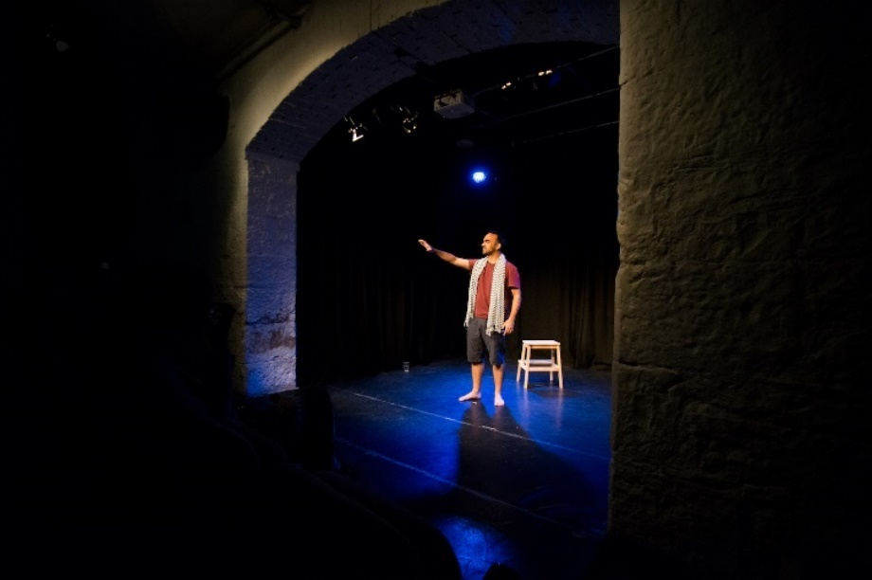

The Mariner’s Song

Solo performance by Rajan Sharma. There is minimal set and gentle lighting. There is an intro to the plot and characters as part of every show. Audiences have permission to move around. Readmittance is allowed.

Which of the following are contained in the show? | Yes/No
Total audience blackout | No
Flashing lights/strobed lighting | No
Loud/repetitive/high pitched/unexpected or overlapping sound | No
Distinctive smells | No
Special effects (e.g. smoke/bubbles/pyrotechnics) | No
Latex balloons | No
Characters expressing anger | No
Heavily dialogue-driven scenes | No
Audience participation | No

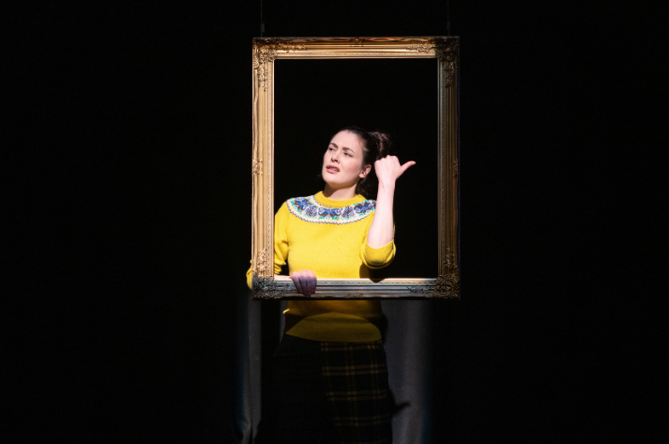

Me, Myself and Mary (Queen of Scots)

Solo performance where Marjolein Robertson plays Mary Fraser, a Shetlander who compares her life to Mary Queen of Scots.

Which of the following are contained in the show? | Yes/No
Total audience blackout | Yes
Flashing lights/strobed lighting | No
Loud/repetitive/high pitched/unexpected or overlapping sound | No
Distinctive smells | No
Special effects (e.g. smoke/bubbles/pyrotechnics) | No
Latex balloons | No
Characters expressing anger | Yes
Heavily dialogue-driven scenes | Yes
Audience participation | No

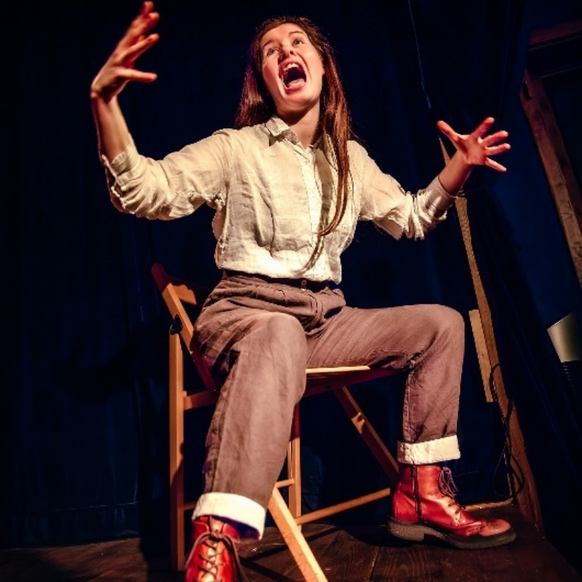

No One Is Coming
Solo show where Sinead O’Brien tells stories from her life as well as Irish mythology and folktales.
Contains distressing or potentially triggering themes:
- In-depth discussion of mental health issues
- Reference to an allegation of sexual abuse against a child
- Description of a medical examination due to sexual assault
- Reference to alcoholism

Which of the following are contained in the show? | Yes/No
Total audience blackout | No
Flashing lights/strobed lighting | No
Loud/repetitive/high pitched/unexpected or overlapping sound | No
Distinctive smells | No
Special effects (e.g. smoke/bubbles/pyrotechnics) | No
Latex balloons | No
Characters expressing anger | Yes
Heavily dialogue-driven scenes | Yes
Audience participation | No

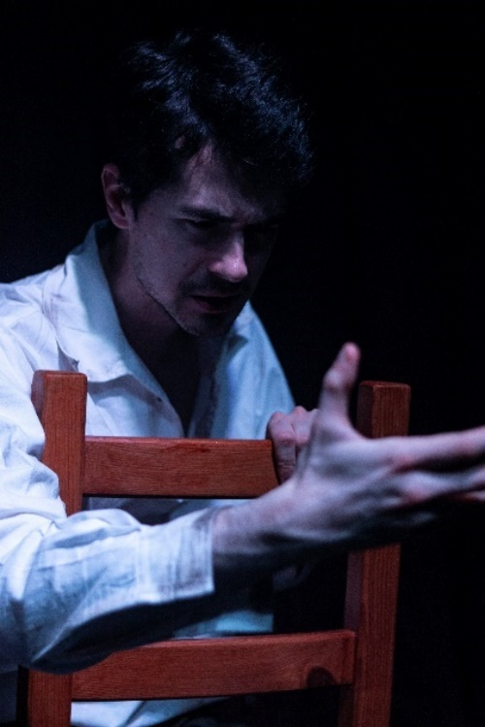

The Rotting Hart
Solo performance by Daniel Orejon. Contains themes of gore and animal cruelty. Contains scenes of a sexual nature, violence and sexual violence. The male performer is topless for the first five minutes of the show. The performer goes into the audience towards the door at one point in the show.
The show is a horror so even a relaxed performance with house lights on might still be sensorily excessive for some audience members. If you need more information in order to make a decision there is a full show guide available.
Captioned Performance Wednesday 9 Aug

Which of the following are contained in the show? | Yes/No
Total Audience blackout | Yes
Flashing Lights/Strobed lighting | No
Loud/repetitive/high pitched/unexpected or overlapping sound | No
Distinctive smells | No
Special effects (e.g. smoke/bubbles/pyrotechnics) | No
Latex balloons | No
Characters expressing anger | Yes
Heavily dialogue-driven scenes | Yes
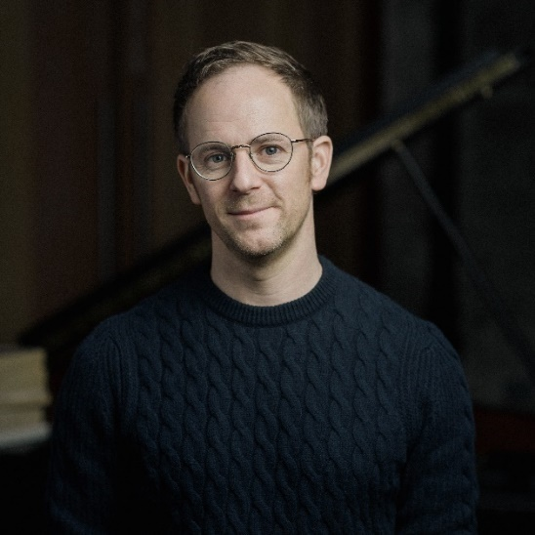

Songs from the Last Page

Storytelling and music performance by Gareth Williams and accompanying musicians.
Gareth has composed songs based on the final pages from Scottish literature. Each song will be introduced with storytelling as part of every show.
BSL Interpreted Performance Thursday 17 Aug
Relaxed Performance Wednesday 16 Aug
- Audience members have permission to move around, make noise and engage with the performer.
- Readmittance is allowed.
- The show will be sold at limited capacity to allow space between audience members.
- Show guide available
Which of the following are contained in the show? | Yes/No
Total Audience Black Out | No
Flashing Lights/Strobed Lighting | No
Loud/repetitive/high pitched/unexpected or overlapping sound | No
Distinctive smells | No
Special effects (e.g. smoke/bubbles/pyrotechnics) | No
Latex balloons | No
Characters expressing anger | No
Heavily dialogue-driven scenes | No
Audience participation | No

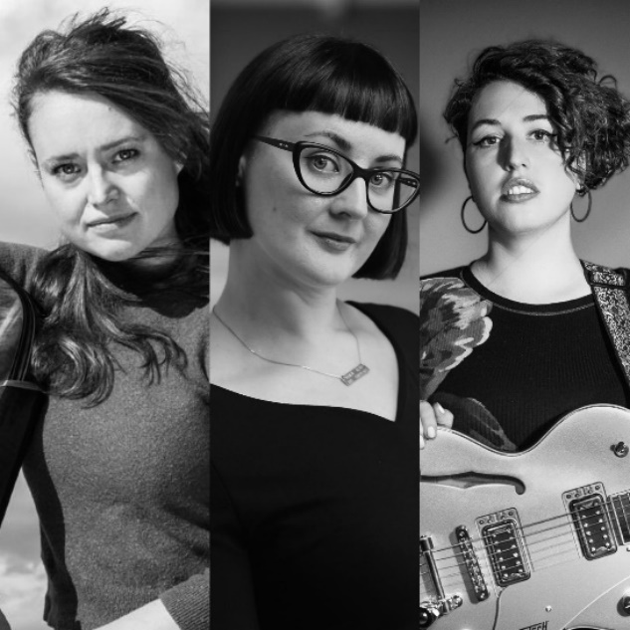

Tam Lin
Storytelling, song and original harp music by Kirsty Law, Kirsty Logan and Esther Swift.
Contains strong language/swearing, mentions of abortion, sexual harassment, violence against women and transphobia.

Which of the following are contained in the show? | Yes/No
Total audience blackout | No
Flashing lights/strobed lighting | No
Loud/repetitive/high pitched/unexpected or overlapping sound | No
Distinctive smells | No
Special effects (e.g. smoke/bubbles/pyrotechnics) | No
Latex balloons | No
Characters expressing anger | Yes
Heavily dialogue-driven scenes | Yes
Audience participation | No

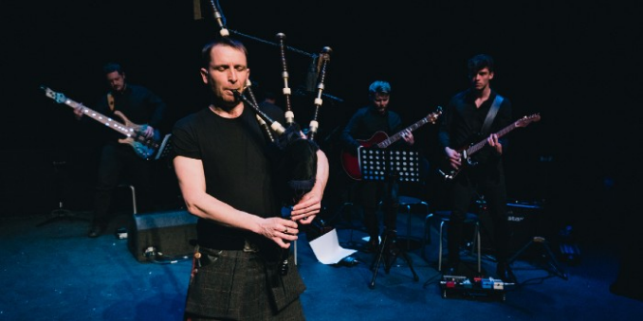

Thunderstruck
David Colvin tells the story of his own experience with bagpiping as well as the story of Gordon Duncan, a legendary piper who changed the art form forever. David embodies characters including himself, his fellow young pipers, his music teacher and Gordon Duncan himself.
Contains very strong language and themes of homophobic bullying, violence and alcohol misuse. Contains some optional audience interaction and loud live music.

Which of the following are contained in the show? | Yes/No
Total audience blackout | Yes
Flashing lights/strobed lighting | Yes
Loud/repetitive/high pitched/unexpected or overlapping sound | Yes
Distinctive smells | No
Special effects (e.g. smoke/bubbles/pyrotechnics) | No
Latex balloons | No
Characters expressing anger | Yes
Heavily dialogue-driven scenes | No
Audience participation | Yes

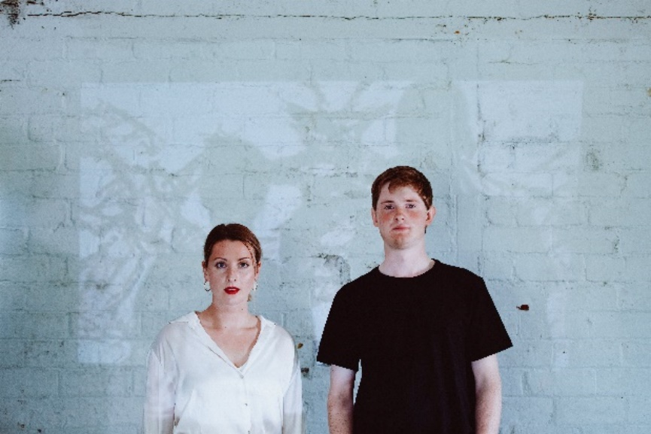

With the Devil’s Assistance

Shona Cowie (storyteller) and Neil Sutcliffe (musician) tell the story of the decline of Scotland’s high streets. The show begins with a town hall-style meeting about the decline of Scotland’s high streets with some audience participation. The performers move through the space and interact with the audience. The remainder of the show tells the folk tale of Maggie Osborne who was burned as a witch for being a successful female business owner. Shona embodies all the characters.
Contains reference to violence against women, sexual harassment and very strong language.
Trailer
Which of the following are contained in the show? | Yes/No
Total audience blackout | Yes
Flashing lights/strobed lighting | Yes
Loud/repetitive/high pitched/unexpected or overlapping sound | Yes
Distinctive smells | No
Special effects (e.g. smoke/bubbles/pyrotechnics) | No
Latex balloons | No
Characters expressing anger | Yes
Heavily dialogue-driven scenes | Yes
Audience participation | Yes

Venue Access Information

Our full access statement with information about each space can be found on our website.
Access Statement

